**Katalon Recorder Documentation**

* Katalon Recorder is a Google Chrome extension. You can dowload and add to Google Chrome from Chrome Web Store Extentations

**GUI:** 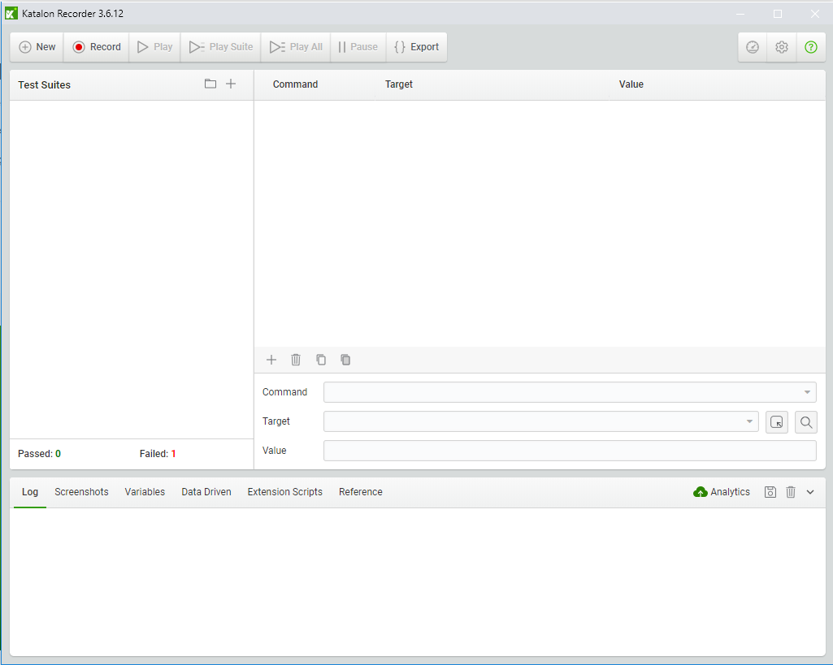

* You need to install **python 3.6** and **selenium** for python.
* After installing python you can add selenium with below command:

***pip –install selenium***

* **For Create New Test Case:**

1. Click New -> Give a Name to Your Test Case
2. Click Record Button and navigate URL.
3. Simulate the test
4. Click Stop Button

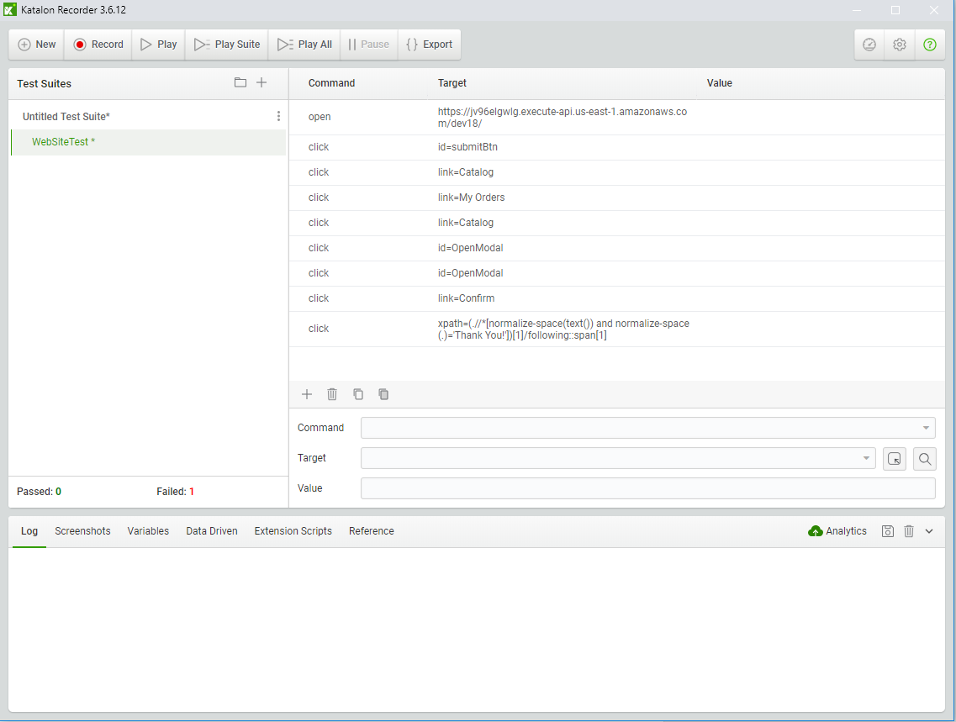

* **Editing Test Case**

You can right click the command line and click add new command where you want to add new command

* **Export the script:**

1. Click Export Button
2. Choose Format of Script
3. Save as File

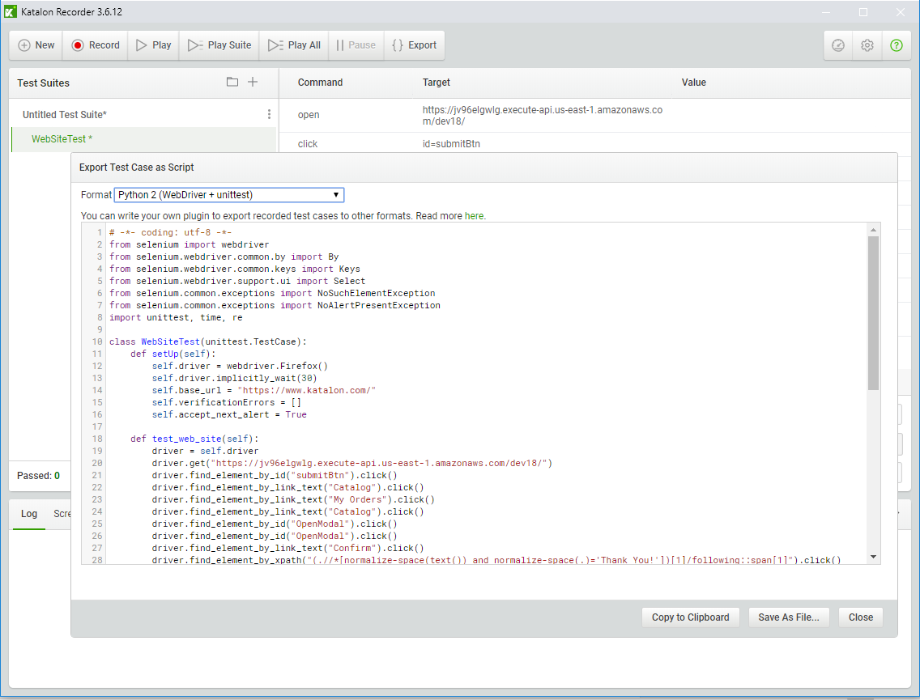

* ***To compile and run python code with selenium, requirements are***

*These 4 steps are for test with Internet Explorer*

1. Open Command Prompt and write regedit
2. Go path given below.

**\HKEY_LOCAL_MACHINE\SOFTWARE\WOW6432Node\Microsoft\Internet Explorer\Main\FeatureControl**

Right click FeatureControl and click new and key labels.

Key name should be **FEATURE_BFCACHE.** Inside this key add new QWORD value. This value name is should be **iexplore.exe** and valuedata is **0.**

1. In the python code add this python code where driver is defined. Inside the **def setUp(self)** block.

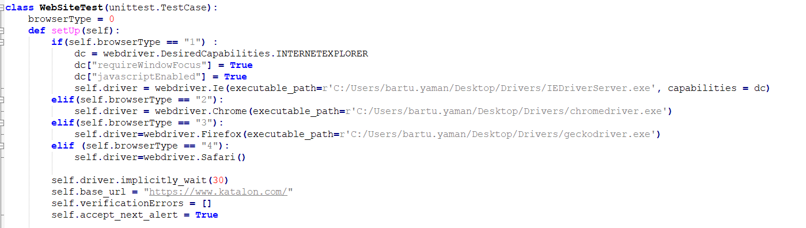

* You can dowload latest version of web driver’s from **https://www.seleniumhq.org/download/**
* For web drivers you should give exact path the driver’s exe.
* Don’t forget the add **import.sys** begining of the .py file. Also your main block should be like this:

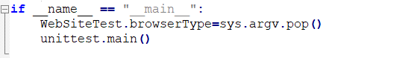

* If you get error about brackets dowload and install Visual Code and reformat your code.

1. For Internet Explorer testing you should do these steps:
   * Click Tools in Internet Explorer and set zoom level as **%100**
   * Click Tools and go Internet Options. In security tabs Set all zones (Internet, Local intranet, Trusted sites, Restricted sites) to the same protected mode, enabled or disabled should not matter.
2. After complate your python code you have to right powershell script to testing your case for all browsers.
3. Your powershell script should be

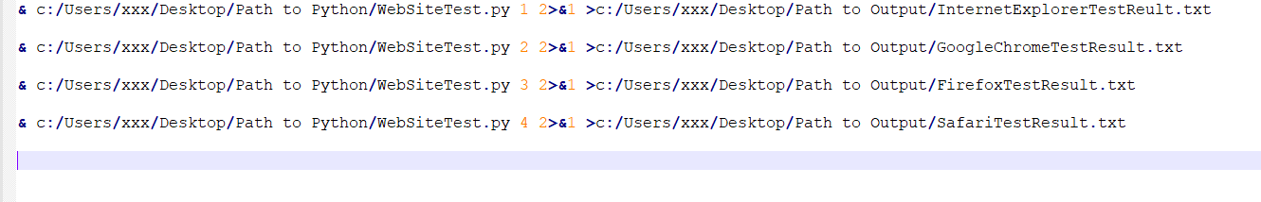

Save the file as powershell script. File extension is .ps1 .

Run your powershell command from Windows Powershell and see results in output files.